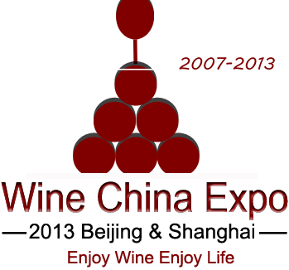
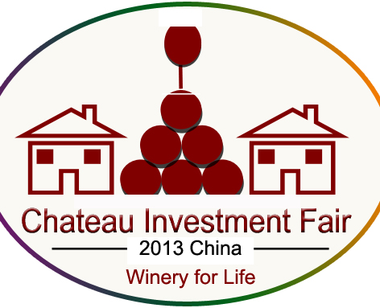
2017 Chateau China Investment Fair
September | Beijing & Shanghai

Chinese fast-growth economy makes more Chinese people become much more rich, and several people have already bought wineries or chateaus in Bordeaux, Rhone, Bourgeoisie, Australia, Chile, Italy, Spain and so on, so if you want Chinese buyer or investors to buy or invest your winery or chateau, please join in Winery Chateau China Investment Fair Beijing and Shanghai.

As the organizer of Wine China Expo 2017 in Beijing and Shanghai, we have rich data of over 30000 trade visitors and also invite those rich people or groups to meet you during Wine China Expo 2017 in Beijing and Shanghai.

How to join in 2017 Winery Chateau Investment Fair? We would like to provide the following service for you:

1st Period in Beijing from September 25 to 27
- to have 6sqm stand with basic standard package with 2-3 posters to show your winery or chateau and show your wines
- to have two seats to be present at Winery Chateau Investment Meeting( September 25) which will invite Chinese experts introduce the situation of Chinese investors
- one 4 color page advertisement on the official catalogue to display your winery and your wine
- to attend Buyers and Sellers Meeting in order to face to face to meet Chinese investors

The cost: USD 1320 / Euro 1200 per company for the above-mentioned service;
The Advertisement rate: USD 660 / Euro 600 per poster (1mx2.5m) or Euro 1000 per link banner (60 pix x 200 pix) on the official website in a year or USD 1100 / Euro 1000 per page on the official catalogue

2nd Period in Shanghai on September 28
- to have one tasting table with one poster to show your winery or chateau and show your wines
- to attend Buyers and Sellers Meeting in order to face to face to meet Chinese investors
- one 4 color page advertisement on the official catalogue to display your winery and your wine

The cost: USD 550 / Euro 500 per company for the above-mentioned service;
The Advertisement rate: USD 330 / Euro 300 per roll-up board (1mx1.4m) or USD 550 / Euro 500 per page on the official guide

Note:
- if you participate at both events in Beijing and Shanghai, the special cost is USD 1650 / Euro 1500 per company
- The brief of your winery and chateau will be published on the official website in one year.
- Besides meeting some potential buyers or investors, you may also meet most of Chinese importers, distributers and agents

Any Inquiry, please contact:

Organizer:

Beijing Regalland Convention & Exhibition Co., Ltd.
Tel: 0086-10-64416542 Fax: 0086-10-64412631
E-mail: info@winechinaexpo.com; winechina@163.com

Application Form for
2017 Chateau China Investment Fair
Deadline: August 20, 2017

We would like to join in 2017 Chateau China Investment Fair that will be held in September in Beijing and Shanghai, which is one of the important events of Wine China Expo 2017. We shall pay the service fee in due and accept the related regulation of hotel and exhibition center.
Company Name:
Company Name (Chinese):
Address:
Tel: | Fax: | Name of Person In Charge
E-mail: | Http:
Do you want to participate at | ( ) Beijing Event ( ) Shanghai Event
The Instruction of the costs
( ) Beijing Event: USD 1320/Euro1200 per stand x (s). = Euro ...........................
( ) Shanghai Event: USD550/Euro500 per table x (s). = Euro ...........................
( ) The AD. Poster in Beijing: USD660/Euro600 per poster x (s). = Euro .................
( ) The AD. Poster in Shanghai: USD330/Euro300 per poster x (s). = Euro ..............
( ) The AD. Banner on the website: USD1100/Euro1000 per banner x (s). = Euro .............
( ) The AD. Banner on the website: USD1100/Euro1000 per banner x (s). = Euro .............
( ) The discount for Beijing and Shanghai Events: USD 220/Euro200

The total amount:

Wine Brands:
Company Brief:(it is available to be attached with this form)

Payment is made by T/T to:
BNF's Name: Beijing Regalland Convention & Exhibition Co., Ltd.
BNF's A/C No.: 11230114040005424 (USD account) or 11230138040000101 (EURO account)
BNF's Bank: Agricultural Bank of China, Beijing Branch SWIFT Code: ABOCCNBJ010

Please send the above form by email To:  Beijing Regalland Convention & Exhibition Co., Ltd.  Tel:0086-10-64416542 Fax:0086-10-64412631  E-mail: info@winechinaexpo.com.com | DATE:
 | SIGNATURE:

